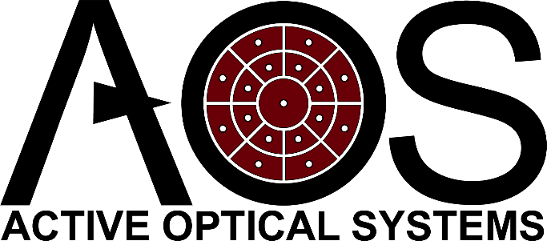
FSM Request for Information
Please complete and submit this form to receive information or a quote pertaining to your specified FSM performance requirements
The FSM Quote Generator is also available to provide rapid cost estimates for AOS Fast Steering Mirrors (VCA only)
Customer Information:
Date: Click or tap to enter a date.
Name: Click or tap here to enter text.
Address: Click or tap here to enter text.
Phone Number: Click or tap here to enter text.
Email: Click or tap here to enter text.
Organization: Click or tap here to enter text.
I am interested in: Select

Product Information:
Quantity: Click or tap here to enter text.
Mirror Diameter (specify units): Click or tap here to enter text.
Mirror Substrate: Click or tap here to enter text.
Clear (Specified) Aperture: Click or tap here to enter text.
Coating Type: Select
Mechanical Travel (± mrad): Click or tap here to enter text.
Angle of Incidence: Click or tap here to enter text.
Surface Figure Accuracy @ 633nm (λ RMS): Click or tap here to enter text.
Bandwidth Requirement (Hz): Click or tap here to enter text.
Resolution/Accuracy (µRad): Click or tap here to enter text.
Volume of FSM & Controller (per component): Click or tap here to enter text.
Vacuum or Space Requirements (specify): Click or tap here to enter text.
Cable Length (FSM to Electronics): Click or tap here to enter text.
Application & Additional Requirements: (Provide Non-CUI information here)

